Software Design Document (SDD)

Lab Assignment 03: ADC

ADC Driver — STM32F411RE

Module | ADC Driver
Version | 1.0.0
Team | Sebastian Lizalde Herrera, Michelle Urbina Carlos, Melanie Picen Hernández
Date | 11/05/2026
Institution | CETYS Universidad

- Introduction

  - Purpose

This document describes the design and architecture of the ADC driver module, based on the requirements defined in the SRS. It provides details on data structures, algorithms, and control flow to guide implementation and testing of the ADC peripheral driver for the STM32F411RE microcontroller.

  - Scope

The ADC driver is a low-level bare-metal software component for the STM32F411RE embedded system. It abstracts hardware registers and provides a clean API for higher-level modules to perform analog-to-digital conversions, including single, continuous, and injected channel conversions.

  - Definitions and Acronyms

Term | Definition
ADC | Analog-to-Digital Converter peripheral on the STM32F411RE.
Channel | Input line connected to the ADC multiplexer (0–18).
Injected Channel | Special ADC channel triggered by software or external events, with separate data registers (JDR1–JDR4).
Regular Channel | Standard ADC channel whose result is stored in the DR register.
Resolution | Number of bits in the digital conversion result. This driver uses 12-bit resolution (0–4095).
Vref | Reference voltage used for conversion scaling; configured externally.
EOC | End Of Conversion flag — set in ADC_SR when a regular conversion completes.
JEOC | End Of Injected Conversion flag — set in ADC_SR when an injected conversion completes.
SRS | Software Requirements Specification.
SDD | Software Design Document.
FR | Functional Requirement.
HAL | Hardware Abstraction Layer — not used in this driver.
DXA | Device-independent eXtension units; 1440 DXA = 1 inch.

  - Requirements

All requirements specific to this module are allocated in the ADC Driver SRS (Version 1.0, Author: Carlos Villarreal, CETYS Universidad). The SRS defines functional requirements FR-1 through FR-9 and non-functional requirements NFR-1 through NFR-3, which this document addresses through the design described herein.

- System Architecture

  - High-Level Design

The ADC driver follows a layered architecture pattern separating application logic from hardware access:

- Application Layer: Calls ADC driver functions (adc_init, adc_setChannel, adc_readData, etc.) to perform analog measurements without any knowledge of hardware registers.
- ADC Driver Layer: Provides the public API defined in adc_driver.h. Implements all business logic including parameter validation, register configuration, and result retrieval.
- Hardware Layer: The actual STM32F411RE ADC1 hardware registers accessed directly through memory-mapped structures (ADC_RegDef_t at base address 0x40012000) and the shared ADC common registers (ADC_Common_RegDef_t at 0x40012300).

  - Module Interfaces

- Public API: All user-facing functions are declared in adc_driver.h. The header also exposes the ADC_RegDef_t and ADC_Common_RegDef_t register map structures, the ADC_Status_t error enumeration, and public constants such as ADC_CHANNEL_MAX and ADC_SAMPLE_TIME_DEFAULT.
- Dependencies: No external library dependencies. The driver requires only stdint.h for fixed-width integer types. RCC and ADC hardware register addresses are defined directly as preprocessor macros within adc_driver.c. The system clock and reference voltage (Vref) must be configured externally before calling adc_init.

- Detailed Design

3.1. Class Diagram
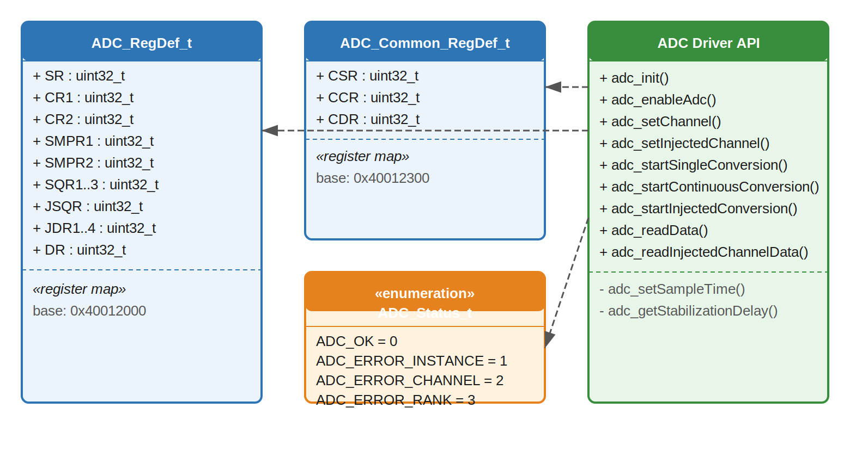
Figure 1. Class Diagram — ADC Driver

3.2. Module Behavior

3.2.1. Sequence Diagram — adc_init
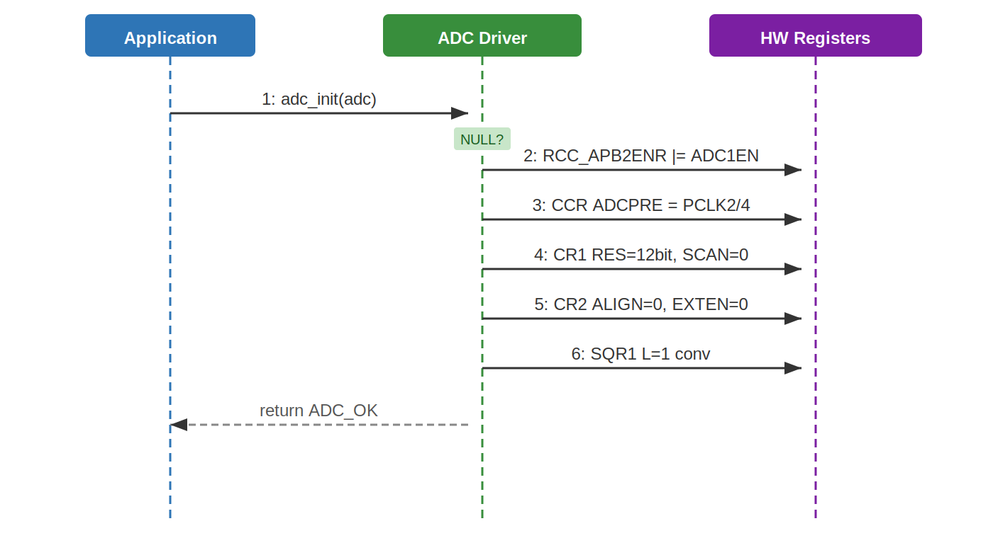
Figure 2. Sequence Diagram — adc_init

3.2.2. Activity Diagram — adc_init
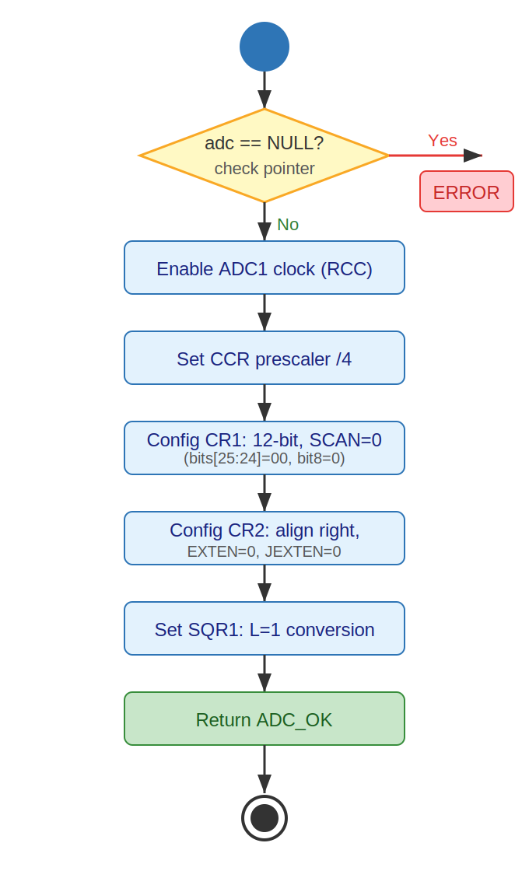
Figure 3. Activity Diagram — adc_init

3.2.3. Sequence Diagram — adc_setChannel (Conditional)
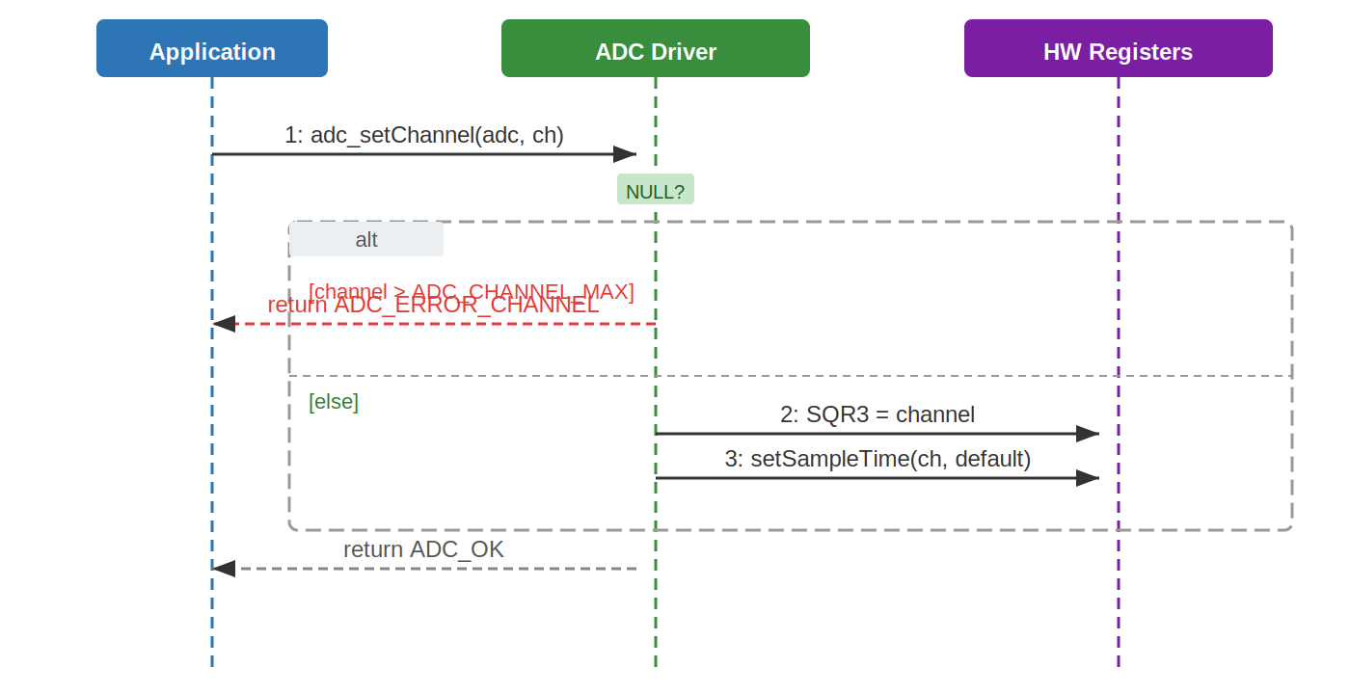
Figure 4. Sequence Diagram — adc_setChannel with Conditional

3.2.4. Activity Diagram — adc_setChannel (Conditional)
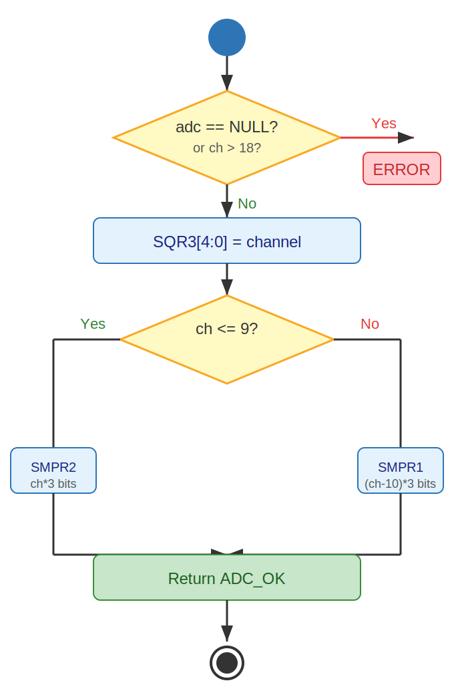
Figure 5. Activity Diagram — adc_setChannel with Conditional

3.2.5. Sequence Diagram — adc_readData (Loop)
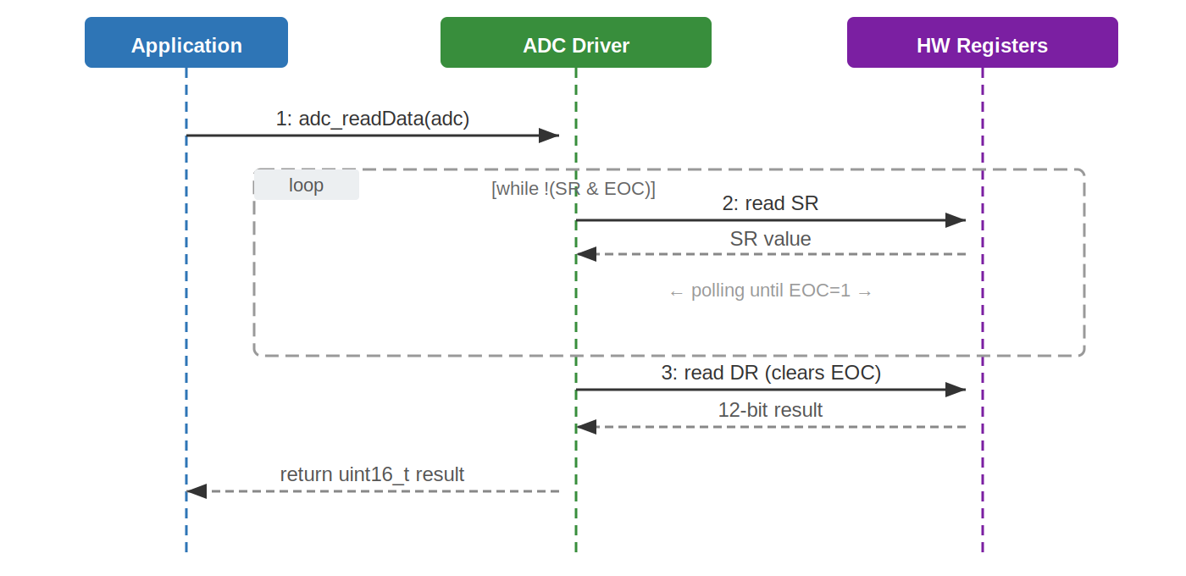
Figure 6. Sequence Diagram — adc_readData with Loop

3.2.6. Activity Diagram — adc_readData (Loop)
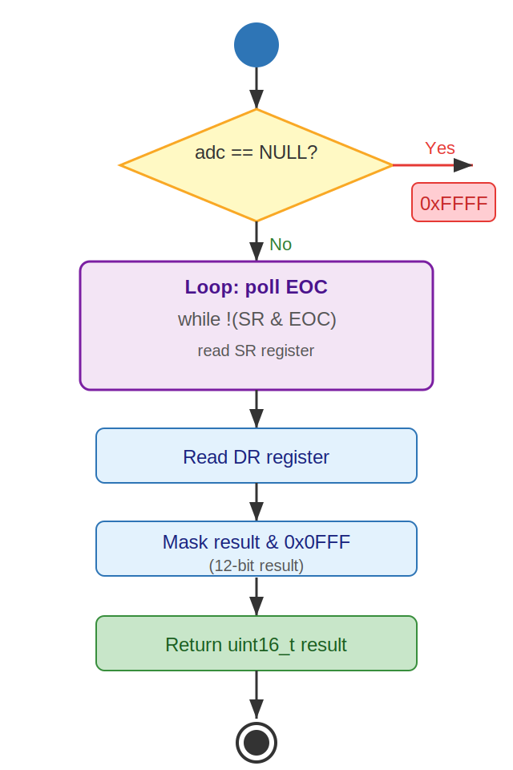
Figure 7. Activity Diagram — adc_readData with Loop

3.2.7. State Diagram — ADC Driver
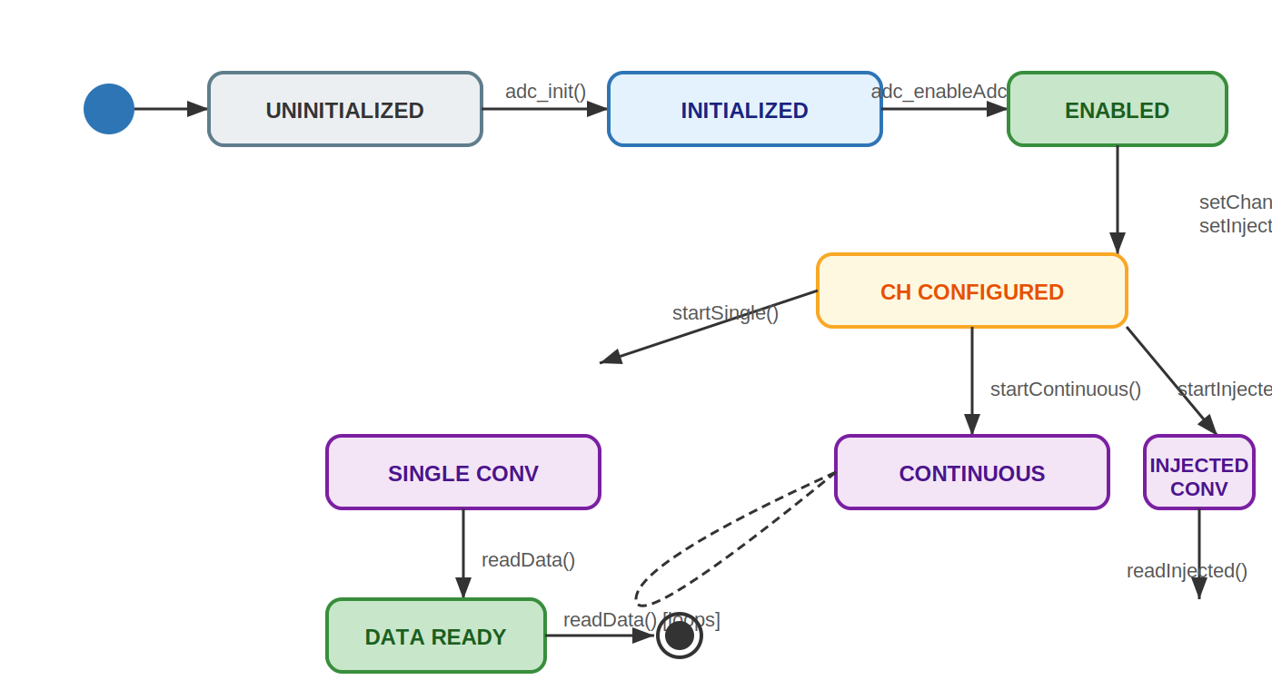
Figure 8. State Diagram — ADC Driver

3.3. ADC Driver

The ADC driver is a stateless, bare-metal C module that directly configures and reads the STM32F411RE ADC1 peripheral through memory-mapped registers as specified in RM0383.

Initialization (FR-1, FR-2): The adc_init function begins by validating the provided ADC instance pointer. If NULL, it returns ADC_ERROR_INSTANCE immediately. Otherwise, it enables the ADC1 clock through the RCC APB2 enable register, sets the shared ADC prescaler to PCLK2/4 via the CCR register, and configures ADC1 for 12-bit resolution (CR1 bits [25:24] = 00), right-aligned data (CR2 bit 11 = 0), disabled scan mode, and no external trigger for either regular or injected conversions. The regular sequence length is set to one conversion (SQR1 bits [23:20] = 0). After initialization, adc_enableAdc sets the ADON bit in CR2 and waits for the ADC to stabilize (~300 cycles), as shown in Figures 2 and 3.

Channel Configuration (FR-3, FR-4): adc_setChannel validates the instance pointer and verifies that the channel number is within the valid range (0–18). It then writes the channel into the SQR3 register (bits [4:0] for rank 1) and sets the sampling time using the internal adc_setSampleTime helper. The helper selects SMPR2 for channels 0–9 or SMPR1 for channels 10–18, writing a 3-bit sampling time code at the appropriate bit offset, as illustrated in Figures 4 and 5. adc_setInjectedChannel performs the same validations, additionally checking the injected rank (1–4), and configures the JSQR register with JL = 0 (one conversion) and the channel in JSQ4 (bits [14:10]).

Conversion Control (FR-5, FR-6, FR-7): adc_startSingleConversion clears the CONT bit in CR2 to ensure single-conversion mode, clears the EOC and STRT status flags, then sets SWSTART (bit 30) to trigger the conversion. adc_startContinuousConversion instead sets the CONT bit before triggering SWSTART, causing the ADC to repeat conversions automatically. adc_startInjectedConversion clears JEOC and sets JSWSTART (bit 22) to trigger a software-initiated injected conversion.

Data Retrieval (FR-8, FR-9): adc_readData polls the EOC flag in the SR register in a blocking loop (Figure 6 and 7). Once EOC is set, it reads the DR register — which automatically clears EOC — and returns the lower 12 bits as a uint16_t. adc_readInjectedChannelData polls JEOC, clears it manually, then returns the 16-bit value from the appropriate JDRx register (JDR1–JDR4) corresponding to the requested rank.

The state diagram (Figure 8) shows the full driver lifecycle: from UNINITIALIZED through INITIALIZED, ENABLED, CHANNEL CONFIGURED, and into the conversion states (SINGLE CONV, CONTINUOUS, INJECTED CONV), culminating in DATA READY when results are available.

- Application Programming Interfaces

4.1. Data Types and Macros

Data Types
- ADC_Status_t: This enumeration represents the return status of all public ADC driver functions. It allows callers to detect and handle errors without inspecting hardware registers directly.

Member Name | Type / Value
ADC_OK | 0 — Operation completed successfully.
ADC_ERROR_INSTANCE | 1 — The ADC instance pointer provided is NULL.
ADC_ERROR_CHANNEL | 2 — The channel number is outside the valid range (0–18).
ADC_ERROR_RANK | 3 — The injected rank is outside the valid range (1–4).

- ADC_RegDef_t: This structure is a direct memory-mapped overlay of the STM32F411RE ADC peripheral registers (RM0383 Section 11). It is instantiated by pointing to the ADC1 base address (0x40012000UL).

Member Name | Type | Notes / Definition
SR | volatile uint32_t | Status Register. Holds EOC, JEOC, STRT flags. Offset: 0x00.
CR1 | volatile uint32_t | Control Register 1. Configures resolution (RES[25:24]) and scan mode. Offset: 0x04.
CR2 | volatile uint32_t | Control Register 2. Controls ADON, CONT, ALIGN, SWSTART, JSWSTART. Offset: 0x08.
SMPR1 | volatile uint32_t | Sample Time Register 1. Configures sampling cycles for channels 10–18. Offset: 0x0C.
SMPR2 | volatile uint32_t | Sample Time Register 2. Configures sampling cycles for channels 0–9. Offset: 0x10.
JOFR1–4 | volatile uint32_t | Injected Channel Data Offset Registers. Offsets: 0x14–0x20.
HTR / LTR | volatile uint32_t | Analog Watchdog higher/lower threshold registers. Offsets: 0x24–0x28.
SQR1 | volatile uint32_t | Regular Sequence Register 1. L[23:20] sets the total sequence length. Offset: 0x2C.
SQR2 | volatile uint32_t | Regular Sequence Register 2. Ranks 7–12. Offset: 0x30.
SQR3 | volatile uint32_t | Regular Sequence Register 3. SQ1[4:0] selects the first channel. Offset: 0x34.
JSQR | volatile uint32_t | Injected Sequence Register. JSQ4[14:10] and JL[21:20]. Offset: 0x38.
JDR1–4 | volatile uint32_t | Injected Data Registers. Hold results of injected conversions. Offsets: 0x3C–0x48.
DR | volatile uint32_t | Regular Data Register. Holds the 12-bit conversion result. Reading clears EOC. Offset: 0x4C.

- ADC_Common_RegDef_t: This structure maps to the shared ADC common registers at base address 0x40012300UL, used to configure the ADC clock prescaler.

Member Name | Type | Notes / Definition
CSR | volatile uint32_t | Common Status Register. Offset: 0x00.
CCR | volatile uint32_t | Common Control Register. ADCPRE[17:16] sets the ADC clock prescaler. Offset: 0x04.
CDR | volatile uint32_t | Common Data Register. Offset: 0x08.

Macros
- ADC1_BASE_ADDR (0x40012000UL): Base address of the ADC1 peripheral in the STM32F411RE memory map (RM0383).
- ADC_COMMON_BASE (0x40012300UL): Base address of the ADC common registers.
- ADC_CHANNEL_MIN (0U): Minimum valid ADC channel number.
- ADC_CHANNEL_MAX (18U): Maximum valid ADC channel number. Channels 0–15 are external, 16–18 are internal (temperature sensor, Vrefint, Vbat).
- ADC_INJECTED_RANK_MIN (1U): Minimum valid injected rank.
- ADC_INJECTED_RANK_MAX (4U): Maximum valid injected rank.
- ADC_SAMPLE_TIME_DEFAULT (0x5U): Default 3-bit sampling time code corresponding to 84 ADC clock cycles (RM0383 Table 66).

4.2. Error Codes

All public ADC driver functions that return ADC_Status_t use the following error codes. Functions returning uint16_t return 0xFFFF to signal an error condition.

Code | Notes / Definition
ADC_OK (0) | Operation was successful. The requested action was performed without errors.
ADC_ERROR_INSTANCE (1) | The ADC instance pointer passed to the function is NULL. No register access is performed.
ADC_ERROR_CHANNEL (2) | The channel number is out of the valid range (0–18). No channel configuration is performed.
ADC_ERROR_RANK (3) | The injected rank is out of the valid range (1–4). No injected channel configuration is performed.
0xFFFF (uint16_t) | Returned by adc_readData and adc_readInjectedChannelData when the ADC instance is NULL or the rank is invalid.

4.3. Function Definitions

adc_init
Function Name | adc_init
Syntax | ADC_Status_t adc_init(ADC_RegDef_t *adc)
Parameters (in) | adc — Pointer to the ADC peripheral register structure (ADC_RegDef_t *). Must point to a valid ADC instance (e.g., (ADC_RegDef_t *)ADC1_BASE_ADDR).
Parameters (inout) | None.
Parameters (out) | None.
Return value | ADC_Status_t — Returns ADC_OK (0) on success. Returns ADC_ERROR_INSTANCE (1) if adc is NULL.
Description | Enables the APB2 clock for ADC1 via RCC_APB2ENR, sets the ADC common clock prescaler to PCLK2/4 in the CCR register, configures ADC1 for 12-bit resolution, right-aligned data, disabled scan mode, and no external triggers for regular or injected conversions. Sets the regular sequence length to 1 conversion. (FR-1)
Constraints | The system clock must be configured before calling this function. This function does not enable the ADC; adc_enableAdc must be called afterward.
Available via | adc_driver.h

adc_enableAdc

Function Name | adc_enableAdc
Syntax | ADC_Status_t adc_enableAdc(ADC_RegDef_t *adc)
Parameters (in) | adc — Pointer to the ADC peripheral register structure.
Parameters (inout) | None.
Parameters (out) | None.
Return value | ADC_Status_t — Returns ADC_OK on success. Returns ADC_ERROR_INSTANCE if adc is NULL.
Description | Sets the ADON bit (bit 0) in CR2 to power on the ADC, then executes a software delay loop (~300 iterations) to allow the ADC voltage regulator to stabilize before any conversion is started. (FR-2)
Constraints | adc_init must be called before adc_enableAdc. The stabilization delay is a busy-wait loop; no hardware-based confirmation of readiness is checked.
Available via | adc_driver.h

adc_setChannel

Function Name | adc_setChannel
Syntax | ADC_Status_t adc_setChannel(ADC_RegDef_t *adc, uint8_t channel)
Parameters (in) | adc — Pointer to the ADC peripheral register structure.  channel — Channel number to configure as the regular conversion source (0–18).
Parameters (inout) | None.
Parameters (out) | None.
Return value | ADC_Status_t — Returns ADC_OK on success. Returns ADC_ERROR_INSTANCE if adc is NULL. Returns ADC_ERROR_CHANNEL if channel > ADC_CHANNEL_MAX (18).
Description | Writes the channel number into SQR3 bits [4:0] (rank 1 of the regular sequence). Calls adc_setSampleTime internally to set the default 84-cycle sampling time for the configured channel. (FR-3)
Constraints | The GPIO pin corresponding to the selected channel must be configured in analog mode externally before starting a conversion.
Available via | adc_driver.h

adc_setInjectedChannel

Function Name | adc_setInjectedChannel
Syntax | ADC_Status_t adc_setInjectedChannel(ADC_RegDef_t *adc, uint8_t channel, uint8_t rank)
Parameters (in) | adc — Pointer to the ADC peripheral register structure.  channel — Channel number to configure (0–18).  rank — Injected sequence rank (1–4).
Parameters (inout) | None.
Parameters (out) | None.
Return value | ADC_Status_t — Returns ADC_OK on success. Returns ADC_ERROR_INSTANCE, ADC_ERROR_CHANNEL, or ADC_ERROR_RANK as appropriate.
Description | Sets JL to 0 (one injected conversion) in JSQR bits [21:20], then writes the channel into JSQ4 (JSQR bits [14:10]). Calls adc_setSampleTime for the configured channel. (FR-4)
Constraints | This driver supports a single injected conversion (JL=0). Multi-rank injected sequences are not supported. The rank parameter is validated but only JSQ4 is used in hardware.
Available via | adc_driver.h

adc_startSingleConversion

Function Name | adc_startSingleConversion
Syntax | ADC_Status_t adc_startSingleConversion(ADC_RegDef_t *adc)
Parameters (in) | adc — Pointer to the ADC peripheral register structure.
Parameters (inout) | None.
Parameters (out) | None.
Return value | ADC_Status_t — Returns ADC_OK on success. Returns ADC_ERROR_INSTANCE if adc is NULL.
Description | Clears the CONT bit in CR2 to disable continuous mode. Clears the EOC and STRT flags in SR. Sets SWSTART (CR2 bit 30) to trigger one software-initiated regular channel conversion. (FR-5)
Constraints | A regular channel must be configured with adc_setChannel before calling this function. The ADC must be enabled with adc_enableAdc.
Available via | adc_driver.h

adc_startContinuousConversion

Function Name | adc_startContinuousConversion
Syntax | ADC_Status_t adc_startContinuousConversion(ADC_RegDef_t *adc)
Parameters (in) | adc — Pointer to the ADC peripheral register structure.
Parameters (inout) | None.
Parameters (out) | None.
Return value | ADC_Status_t — Returns ADC_OK on success. Returns ADC_ERROR_INSTANCE if adc is NULL.
Description | Sets the CONT bit in CR2 to enable continuous mode, clears the EOC flag, then sets SWSTART to begin the first conversion. The ADC repeats conversions automatically after each completes. (FR-6)
Constraints | To stop continuous conversions, the CONT bit or ADON bit must be cleared externally. No stop function is defined in this driver version.
Available via | adc_driver.h

adc_startInjectedConversion

Function Name | adc_startInjectedConversion
Syntax | ADC_Status_t adc_startInjectedConversion(ADC_RegDef_t *adc)
Parameters (in) | adc — Pointer to the ADC peripheral register structure.
Parameters (inout) | None.
Parameters (out) | None.
Return value | ADC_Status_t — Returns ADC_OK on success. Returns ADC_ERROR_INSTANCE if adc is NULL.
Description | Clears the JEOC flag in SR, then sets JSWSTART (CR2 bit 22) to trigger a software-initiated injected channel conversion on the channel configured via adc_setInjectedChannel. (FR-7)
Constraints | An injected channel must be configured with adc_setInjectedChannel before calling this function.
Available via | adc_driver.h

adc_readData

Function Name | adc_readData
Syntax | uint16_t adc_readData(ADC_RegDef_t *adc)
Parameters (in) | adc — Pointer to the ADC peripheral register structure.
Parameters (inout) | None.
Parameters (out) | None.
Return value | uint16_t — 12-bit conversion result (0–4095) on success. Returns 0xFFFF if adc is NULL.
Description | Polls the EOC flag in SR in a blocking loop. Once EOC is set (conversion complete), reads the DR register — which automatically clears EOC per RM0383 — and returns the lower 12 bits as the conversion result. (FR-8)
Constraints | This function is blocking; it will loop indefinitely if a conversion never completes. No timeout mechanism is implemented. Caller is responsible for ensuring a conversion was started before calling.
Available via | adc_driver.h

adc_readInjectedChannelData

Function Name | adc_readInjectedChannelData
Syntax | uint16_t adc_readInjectedChannelData(ADC_RegDef_t *adc, uint8_t rank)
Parameters (in) | adc — Pointer to the ADC peripheral register structure.  rank — Injected rank to read (1–4).
Parameters (inout) | None.
Parameters (out) | None.
Return value | uint16_t — 16-bit injected conversion result on success. Returns 0xFFFF if adc is NULL or rank is out of range.
Description | Polls the JEOC flag in SR in a blocking loop. Once JEOC is set, clears it manually, then reads and returns the value from the JDRx register corresponding to the given rank (JDR1 for rank 1, JDR2 for rank 2, etc.). (FR-9)
Constraints | Blocking function with no timeout. Returns 0xFFFF for invalid rank without performing any register access.
Available via | adc_driver.h

4.4. Internal Function Definitions

adc_setSampleTime

Function Name | adc_setSampleTime
Syntax | static void adc_setSampleTime(ADC_RegDef_t *adc, uint8_t channel, uint8_t sampleTime)
Parameters (in) | adc — Pointer to the ADC peripheral register structure.  channel — ADC channel (0–18).  sampleTime — 3-bit sampling time code (0–7, see RM0383 Table 66).
Parameters (inout) | None.
Parameters (out) | None.
Return value | void — No return value.
Description | Selects the appropriate sample time register: SMPR2 for channels 0–9 (3 bits per channel starting at bit channel*3) or SMPR1 for channels 10–18 (3 bits per channel starting at bit (channel-10)*3). Clears the existing 3-bit field and writes the new sampling time code.
Constraints | Input values are assumed to be pre-validated by the calling public function. No NULL or range check is performed internally.

adc_getStabilizationDelay

Function Name | adc_getStabilizationDelay
Syntax | static uint32_t adc_getStabilizationDelay(void)
Parameters (in) | None.
Parameters (inout) | None.
Parameters (out) | None.
Return value | uint32_t — Always returns 0 (dummy value to prevent compiler optimization of the delay loop).
Description | Executes a busy-wait loop of approximately 300 iterations to provide the ADC voltage regulator stabilization time (~3 microseconds at 84 MHz) required after setting ADON, per RM0383 Section 11.4.
Constraints | The delay duration is approximate and depends on system clock frequency. Not suitable as a precise timing source.

- Future Enhancements

- Timeout mechanism: Add a maximum iteration count to the EOC and JEOC polling loops in adc_readData and adc_readInjectedChannelData to prevent indefinite blocking in case of hardware failure.
- DMA support: Implement DMA-based data transfer for continuous conversion mode to allow non-blocking ADC operation.
- Interrupt-driven conversions: Add interrupt configuration and ISR registration for EOC and JEOC events, enabling asynchronous data retrieval.
- Multi-rank regular sequences: Extend adc_setChannel to support configuring multiple channels in a regular sequence (SQR1–SQR3) with configurable sequence length in SQR1.
- Multi-rank injected sequences: Extend adc_setInjectedChannel to support JL > 0 and multiple injected ranks.
- Configurable resolution: Allow the caller to specify 6, 8, 10, or 12-bit resolution via CR1 RES[25:24].
- Configurable sampling time: Expose the sampling time parameter in the public API instead of using a hardcoded default.
- Analog watchdog support: Implement configuration of the HTR and LTR threshold registers and the analog watchdog interrupt.
- Calibration: Implement the ADC self-calibration procedure as described in RM0383 Section 11.9 to improve conversion accuracy.

